Activity No: 4.3
Activity Title: Sorting and Searching Arrays

Course Code: CPE 007 | Program: Computer Engineering
Course Title: Programming Logic and Design | Date Performed: 09/09/2026
Section: CPE11S4 | Date Submitted: 09/09/2026
Name(s): Lozano, Molier Vincent D. | Instructor: Sir Robin Valenzuela
Objectives
Instructions
Output/Answer
- Write a program that asks for a number from the user and prints which day of the week that number corresponds to. The days are indexed from 0 (Sunday) to 6 (Saturday). Before the program gets a value from the array, it must first check if the given day is greater than or equal to zero and less than 7. If not, it should print the message: "Error, no such day." Your version of the program must print the same result as the expected output.

Code:
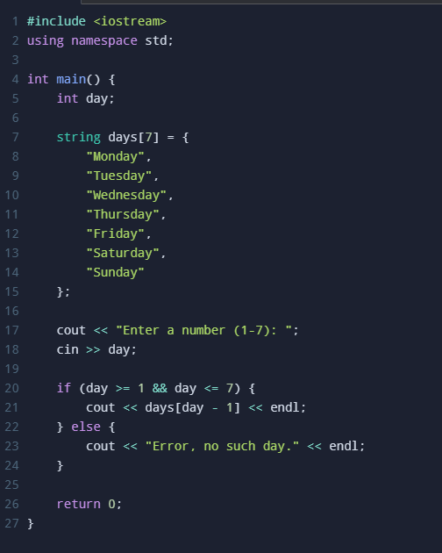

Output:
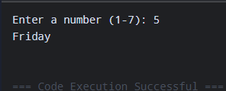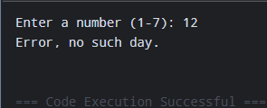

- Write a program that creates a chessboard, sets all the pieces on it and then displays the contents of the board. Create a two-dimensional array, fill it with data and print a letter when a piece is on the field and a space when there is no piece. Store one letter for one piece. For now, we don't need any information about the color of the pieces. The starting positions (with letters which symbolize each piece) for all pieces are: The rooks (R) are placed on the outside corners, right and left edge (white on the 1st and black on the 8th line). The knights (N) are placed immediately inside of the rooks. The bishops (B) are placed immediately inside of the knights. The queen (Q) is placed on the central square of the same color as that of the player: white queen on the white square and black queen on the black square. Both stand on the d rank: white queen on the d1 field and black queen on the d8 field. The king (K) takes the vacant spot next to the queen. The pawns (P - not the official symbol, but you need to print something) are placed one square in front of all of the other pieces. Your version of the program must print the same result as the expected output.
Code:
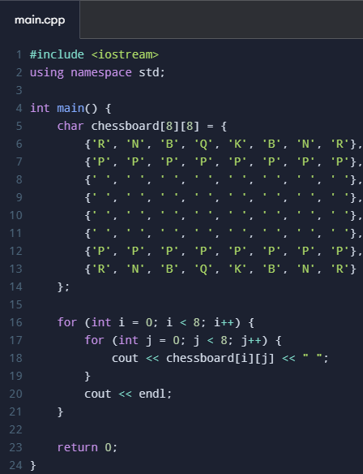

Output:
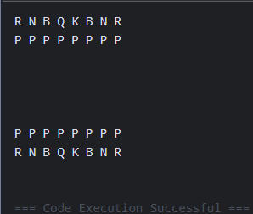
Supplementary Activity (if any)
Conclusion
Assessment Rubric: SO 7

